Installation of Minikube on Local using Windows Package Manager:

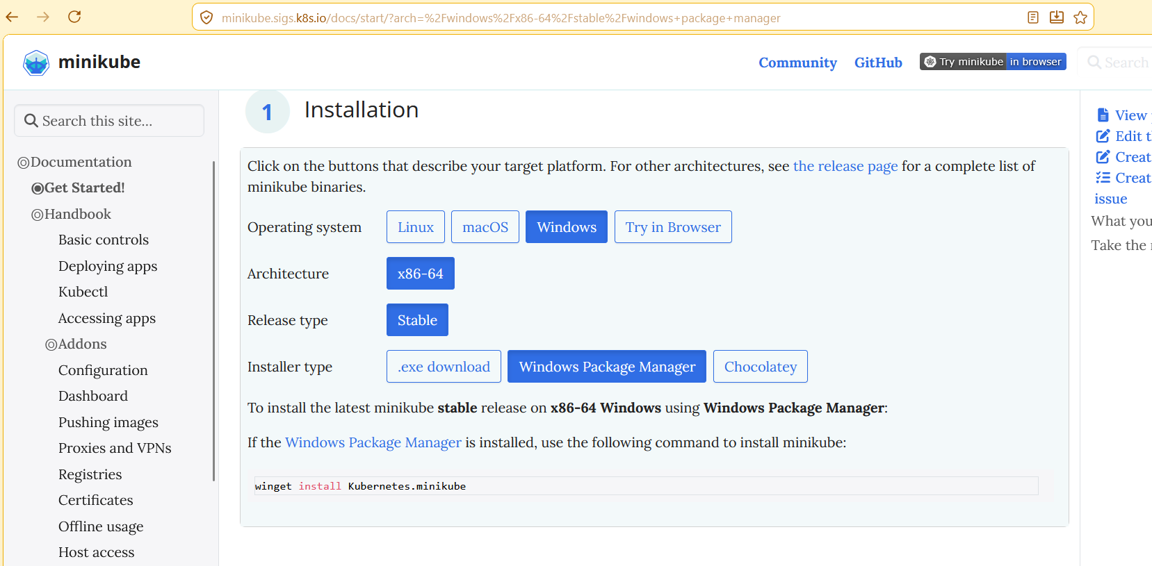

Docker Desktop on Local:(Docker Desktop needed for Minikube to start)
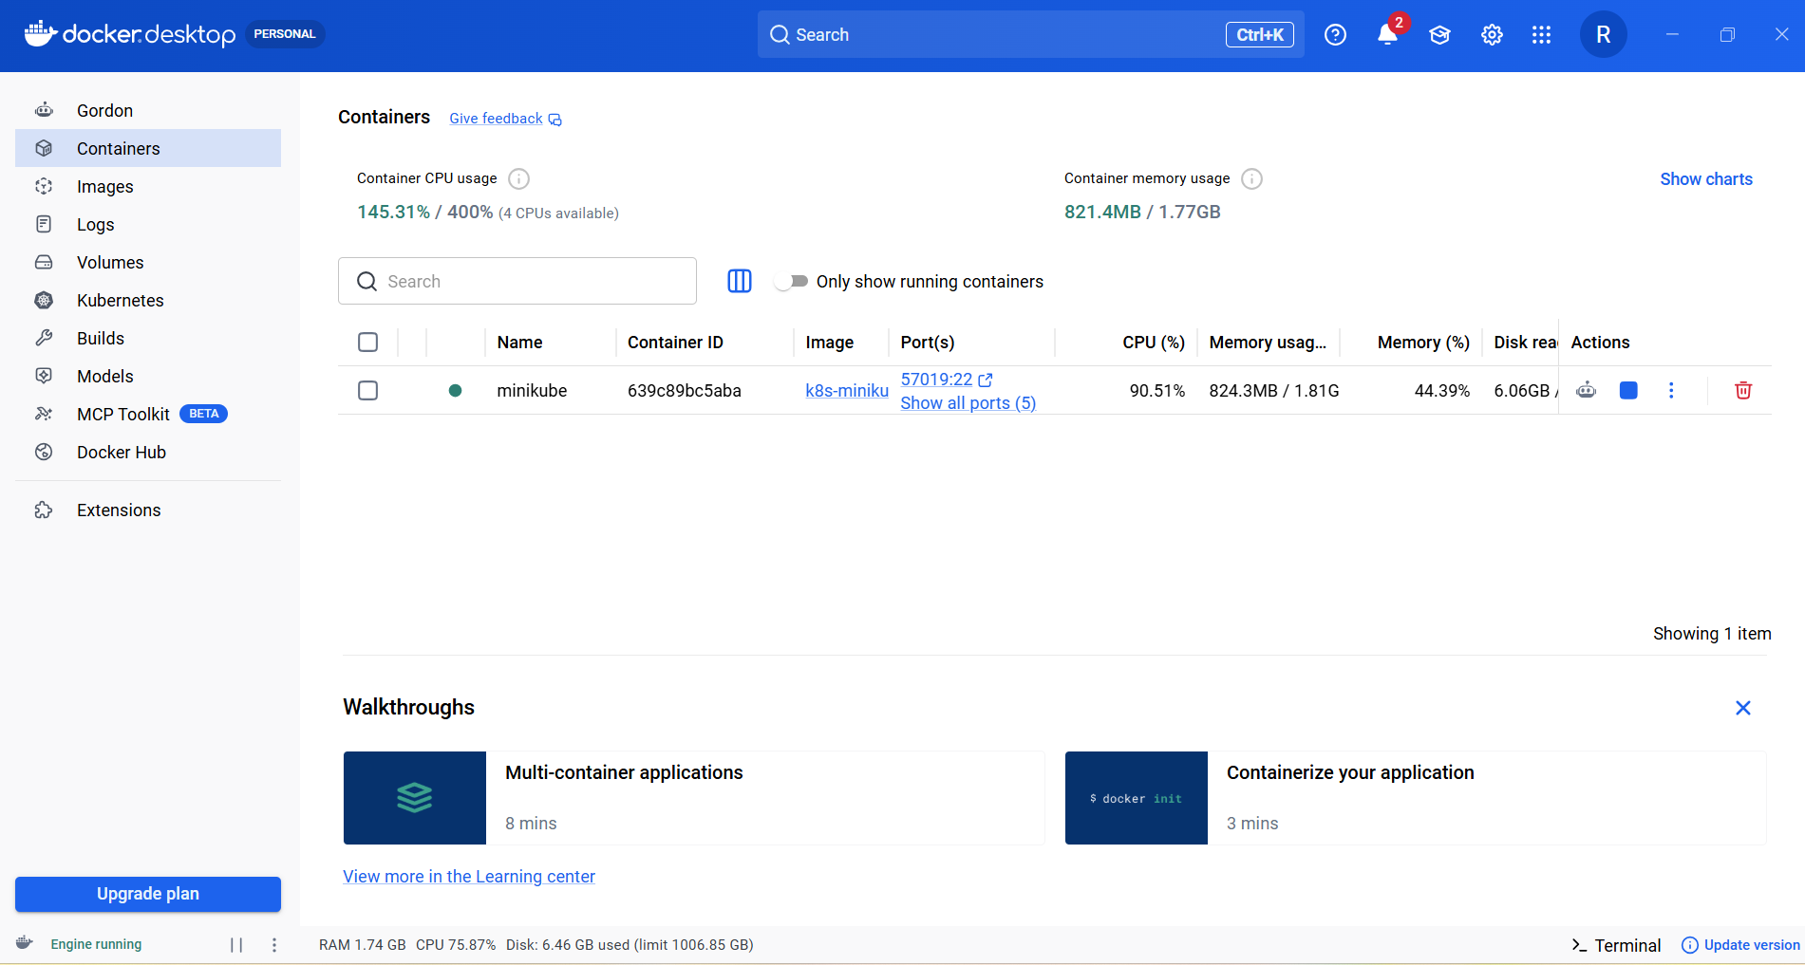

Minikube start:

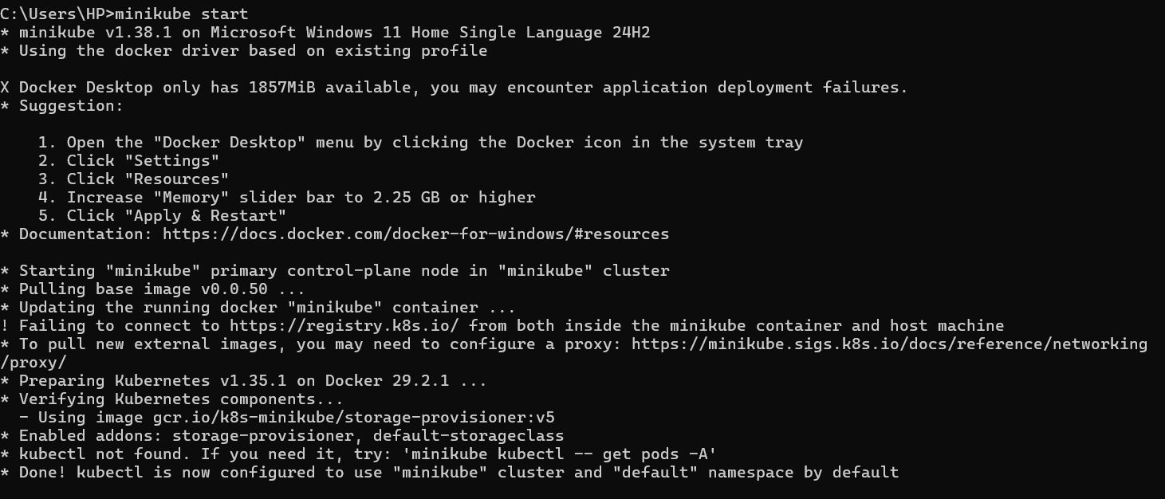
Namespaces:
